

DESKTOP PUBLISHING PROJECT

REPORT

Submitted by:- Submitted to:

NAME-Ritik Thakur Name:- Asst. Prof. Jasleen Kaur

UID- 23BCA10445 SECTION- 3(A)

PROJECT TITLE- BMW magazine

**CONTENTS: -**

1. INTRODUCTION…………………………………………………

The goal of this project is to develop creative skills in designing BMW magazine that cater to various contexts, keeping in mind the principles of visual hierarchy, color theory, typography, and user engagement. Through this project, participants will learn to use design tools, explore layout strategies, and understand the significance of branding in BMW magazine creation.

1. OBJECTIVE OF PROJECT……………………………………..

The objective of this project is to design visually appealing and effective BMW magazine that communicate messages clearly, align with branding goals, and engage the target audience across various digital and print platforms.

1. PROCEDURE OF DESIGNING……………………………..

Followed the right steps for creating BMW

magazine using Adobe photoshop.

1. PROJECT OUTPUT IMAGES…………………………………

Pasted the results of BMW magazine designing.

5. CONCLUSION………………………………………………….

This project highlights the importance of well- designed BMW magazine in communication and branding. By applying design principles, creative tools, and layout techniques, participants gain valuable skills to create effective BMW magazine that capture attention and deliver messages clearly across different platforms.

**BMW magazine Design Using Adobe Photoshop**

# Introduction:

BMW magazine design is a creative process that involves combining text, imagery, and graphic elements to communicate messages effectively. It serves various purposes, such as promoting events, advertising products, or spreading awareness. Adobe Photoshop is a powerful tool that allows designers to bring their ideas to life, offering a wide range of features for photo editing, typography, and layout creation.

# Objective:

The objective of this project is to design a visually appealing BMW magazine using Adobe Photoshop that effectively communicates a specific message, captures attention, and aligns with the intended theme or purpose.

* 1. Learning essential BMW magazine design principles.
  2. Mastering Photoshop tools like layers, text, and effects.
  3. Designing a BMW magazine with specific dimensions

and resolution.

* 1. Applying creativity and branding consistency.
  2. Exporting the BMW magazine in formats suitable for

web or print.

Step-by-Step Guide to Designing the BMW Magazine Cover in Photoshop

Step 1: Set Up the Document

Open a New Document:

Go to File > New.

Set the dimensions to 8.5 x 11 inches (standard magazine

size) with a 300 DPI resolution for print quality.

Use the CMYK color mode for printing. Step 2: Import the Background Image

Place the Car Image:

Go to File > Place Embedded and select the BMW car image.

Position the image so that the car is aligned to the left side of the document, filling approximately half of the cover.

Resize the image if needed by holding Shift while dragging

the corners to maintain aspect ratio.

Create a Split Layout with a White Rectangle:

Use the Rectangle Tool (U) to draw a white rectangle

covering the right half of the cover.

Position it carefully to achieve a balanced split between the image and the white area.

Step 3: Add the Magazine Title

Add "BMW" Text:

Select the Text Tool (T), click on the canvas, and type "BMW" in uppercase using a bold sans-serif font (like Arial Black).

Position this at the top left of the white area, near the edge

of the split.

Set the color to black for contrast.

Add "MAGAZINE" Text:

Below "BMW," type "MAGAZINE" using a bold, sans-serif font in orange for a bold visual.

Adjust the size so that it aligns visually with "BMW" and

position it directly under or next to "BMW."

Step 4: Add the Main Headline ("WOLF IN SHEEP CLOTH")

Create the Headline Text:

Use the Text Tool to type "WOLF IN SHEEP CLOTH" with each word on a separate line.

Choose a bold font and set the text color to black for most of the words, while using red or a gradient overlay on "SHEEP" and "CLOTH" for emphasis.

Apply a Clipping Mask Effect (Optional):

To create the effect where the car image appears within the text, duplicate the car layer and move it above the text layer.

Right-click on the image layer and select Create Clipping Mask to clip the car image into the headline text, giving it that "cut-out" appearance.

Adjust the position of the clipped image until the car details (like headlights) align well within the letters.

Step 5: Add the Subheadline and Supporting Text

Add "#01 BMW SUPERCAR COLLECTION":

Use the Text Tool to type "#01 BMW SUPERCAR

COLLECTION" near the bottom left of the cover.

Use a bold sans-serif font and set the text color to orange to complement "MAGAZINE."

Position this over the black area of the image, aligned for balance.

Step 6: Add Design Elements

Add a Border:

Use the Line Tool (U) to create a thin black border around the

entire cover.

Set the line thickness to 2-3 pixels.

Insert the BMW Logo:

Go to File > Place Embedded to insert the BMW logo at the bottom-right corner of the cover.

Scale it down if necessary, positioning it to balance the design without distracting from the main headline.

Step 7: Fine-Tune and Adjust

Adjust Color and Contrast:

Use Adjustment Layers (under Layer > New Adjustment Layer) like Brightness/Contrast or Levels to refine the image’s look.

Add Subtle Effects:

For added depth, you can apply a Drop Shadow to the text layers by right-clicking on each text layer, selecting Blending Options, and enabling Drop Shadow.

Customize the shadow settings for subtle depth and emphasis.

Step 8: Save and Export

Save Your Work:

Save your file as a PSD to retain all layers for future edits.

Export for Print:

Go to File > Export > Export As, choose JPEG or PDF format, and ensure the resolution is 300 DPI for printing.10. REVIEW AND FEEDBACK: -

Review the final BMW magazine for any design or content errors.

Share the design with stakeholders or team members for feedback and make necessary revisions.

OUTPUT IMAGE: -

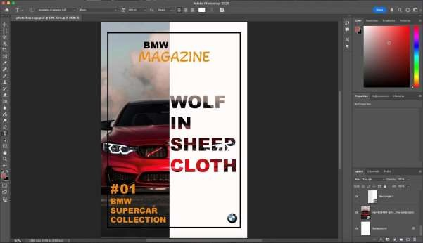

**Conclusion:**

Designing a BMW magazine using Adobe Photoshop is a comprehensive process that combines creativity with technical skills. Through this project, users learn how to effectively use tools like typography, imagery, and graphic elements to convey messages in a visually engaging way. The steps covered—ranging from setting up the canvas to applying effects and exporting—ensure a polished final product suitable for both digital and print platforms. This project not only enhances proficiency in Photoshop but also provides valuable insights into design principles, helping participants create professional BMW magazines that align with the desired theme and purpose.